Year 6 Summer Term 1

Let’s Get Ready

Bonneville Driver: Communication

**As effective communicators, we will write and publish short stories and novels and produce speeches.**

Bonneville Driver: Enterprise

**As enterprising people we will be working in groups on a class enterprise project.**

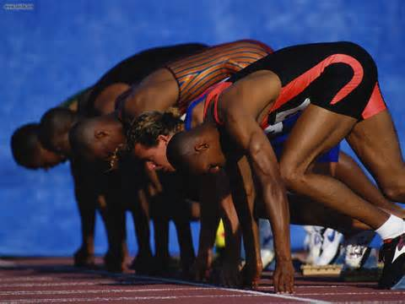picture

picture

**This topic helps prepare us for SATS. We will be revising all key topics and subjects across the curriculum. Alongside this we will continue to study ancient Greece through art, history and geography. We will conduct our own independent studies in order to be fully prepared for the SATS.**

Trips and Visitors: Junior Citizens Event, local area visits, Blackland Farm

Exit Activity: Greek Day (carried over from Spring 2)

Numeracy: Linked Learning

Revision of all topics

Literacy: Genres and Texts

Narrative

Formal Writing

Bonneville Driver: Environment

**Investigating land use in different city states in Ancient Greece**

Bonneville Driver: Possibilities

**As aspirational people, we will recognise that we can solve problems and invent solutions.**



**As Scientists we will be learning about**

* the circulatory system
* the digestive system
* the effects of drugs on the human body

**As Artists we will be**…

* Sketching and evaluating our artwork.
* Making our Greek pots using Mod Roc

**As Sports people we will be developing our athletics skills outside and honing our rugby prowess.**

**Our SMSC Learning:**

We will be researching legal and illegal drugs and the effects on the body.

**As Musicians we will be…**

Learning the songs for our end of year play.

**The religion we will study:**

**(Lambeth Agreed Syllabus)**

**Make connections between world religions (Judaisim, Buddhism, Islam)**

**Our Spanish learning:**

**We will be revising our previous learning of Spanish life.**

**As Computors we will be…**

* **Creating short films using a range of tools and software.**

**As Historians we will be…**

* Comparing two different Greek City
* Using a range of secondary sources to investigate the past and presenting their findings.

**As Geographers we will be…**

* Describing an ancient Greek landscape.
* Investigating physical and human features of land use in Ancient Greece

Year 6 Term Summer 1

Let’s Get Ready