Bonneville Driver: Communication

As effective **communicators**, we will use our sequencing skills to help us re-tell stories in order.

Bonneville Driver: Enterprise

* As **enterprising** people we will raise awareness and money for Oxfam for the Nepalese Earthquake appeal.

Year 2 Summer Term 1

Location, location, location

picture

**This topic explores the similarities and differences between our local environment in London and that of Kathmandu, Nepal. Children will use maps, globes and atlases to investigate the physical and human features associated with each.**



Trips and Visitors: **A guest speaker to talk about Nepalese culture. If you would like to volunteer yourself or anyone you know please see your child’s class teacher.**

Exit Activity: **A trip to a Hindu temple.**

Topic Vocabulary:

Physical and human features

Map

Atlas

Globe

Key

Country

Continent

ocean

North, South, East and West.

Literacy: Genres and Texts

We will be focusing on the story of ‘How the Elephant got his trunk’. We will be using this to create our own stories. In grammar we will be learning about adjectives, nouns, verbs, adverbs, conjunctions, the use of past and present tense and punctuation.

Numeracy: Linked Learning

Place value

Addition

Subtraction

Multiplication

Division

Measurement (Mass)

Geometry

Statistics

Fractions

Applying to worded problems

Time

Bonneville Driver: Possibilities

As **aspirational** people, we will explore the jobs of different leaders around the world and the impact they have.

Bonneville Driver: Environment

As **people concerned with the environment**, we will investigate how to live in a sustainable world.

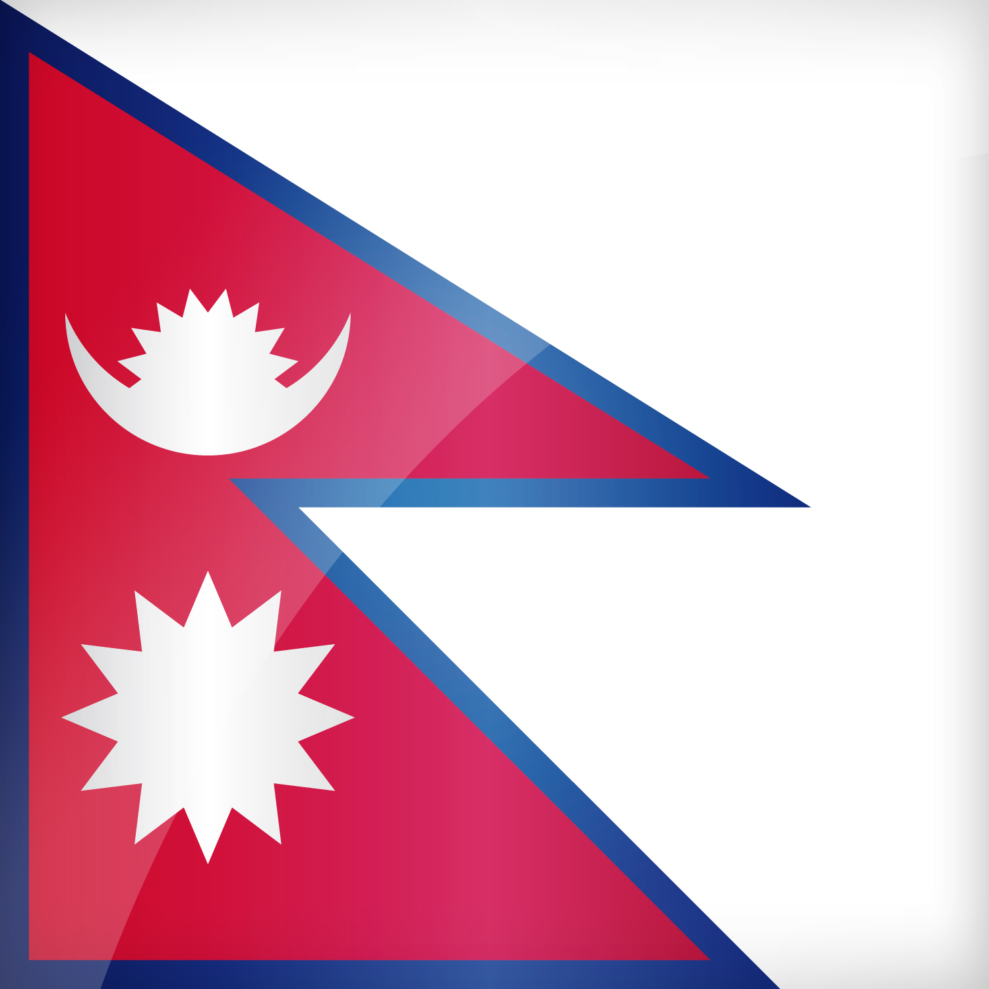

**As Geographers we will be…**

* Learning about the human and physical features of the local area and Nepal.
* We will use maps, globes and atlases to identify countries, continents and oceans around the world.
* We will learn how to use North, South, East and West to describe the position.

**As Athletes we will be…**

* Using bat and ball skills.
* We will develop hand and eye co-ordination.
* We will develop our team skills.

**The religion we will study:**

**(Lambeth Agreed Syllabus)**

Hinduism. We will learn about living as a Hindu.

**Our SMSC Learning:**

* Respecting equality and diversity in relationships.

**As Musicians we will be…**

* Listening to and exploring a range of Nepalese music.

**As Scientists we will be…**

Learning about plants through:

* Observing the conditions of how seasoned bulbs grow.
* Observing and noting the ways that plants change as they grow.

Year 2 Summer Term 1

Location, location, location.

**As Artists we will be**…

* Learning about various Nepalese art forms and artists.
* Using a range of materials we will creatively develop a wide range of art and design techniques including using pattern, line, shape and colour to replicate art forms in different styles.
* Using printing techniques to create prints linked to Nepalese art.

**As Computors we will be…**

* Using Data Handling: Collecting, Analysing, Evaluating and Presenting Data linked to Nepal.