Bonneville Driver: Enterprise

**As enterprising people we will…**

Designing and making our own toys which will then be displayed in our own museum.

Bonneville Driver: Communication

**As effective communicators, we will…**

Be using role play to dramatise characters.

Using talk partners to share and modify ideas.

We will share our ideas and knowledge about toys through history.

We will present toy designs to an audience.

Year 1 Summer 1

Toy Story

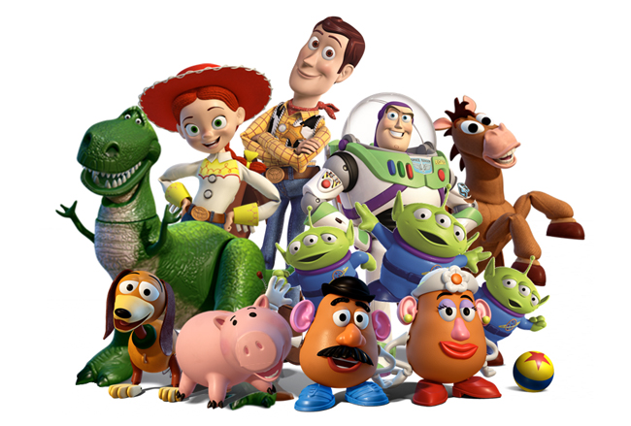picture

Trips and Visitors:

Museum of Childhood – to look at toys throughout history.

Mosque – We will be visiting a local mosque to learn more about Islam.

Exit Activity – Making our own toy museum.

Numeracy: Linked Learning

**Measure:**

Measuring capacity, length and mass; telling and reading time. Adding money using coins and notes.

**Calculations:**

Inverse operations, missing numbers, multiplication and blank number lines.

**Geometry:**

Movement and direction. Learning the properties of 3D shapes.

**Place Value:**

Writing numbers as words, knowing the value of each digit.

**Fractions:**

Division and sharing.

Literacy: Genres and Texts

**Fantasy Settings** – We will explore a range of fantasy stories focusing on the setting, characters and why fantasy stories are fun.

We will then use this to amend an existing fantasy story.

Bonneville Driver: Environment

**As people concerned with the environment, we will**…

Be looking at how plants grow and how we can produce our own food to be sustainable.

Bonneville Driver: Possibilities

**As aspirational people, we will**…

Learn about a variety of famous toy designers throughout history and take on their role as toy designers.

**This topic explores toys throughout history. It looks at how toys have changed over time and how they have evolved and developed. Children will understand how toys work and what they are made of; which will support them as toy designers/makers. We will research where toys have come from and create our own toy museum.**

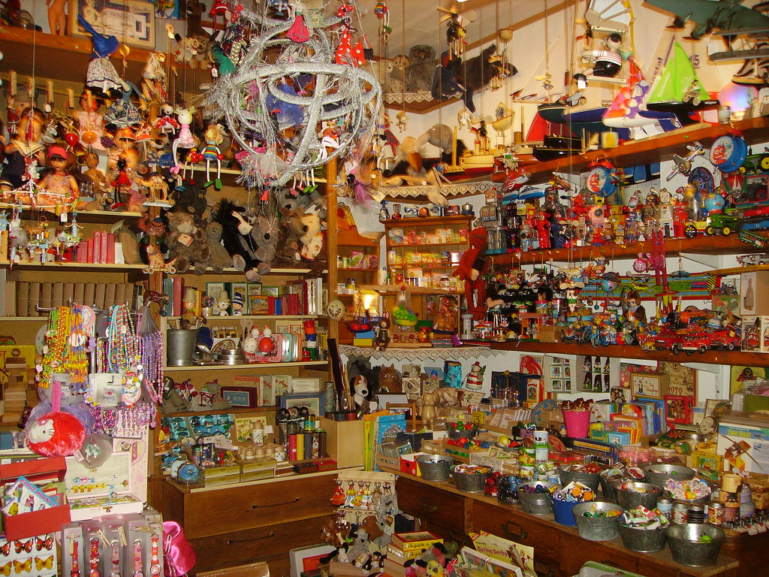

**The religion we will study:**

**(Lambeth Agreed Syllabus)**

Islam Unit: Muslim Beliefs. We will look at what Muslims believe about Allah and how they go about their daily lives as Muslims.

**Our PSHE Learning: Understanding and Peace.**

* Showing empathy and understanding that our behaviour can affect others.
* Knowing the importance of positive thoughts and actions and working collaboratively.

**Topic Words.**

old push

new pull

moving electric

lever history

wooden metal

plastic

Year 1 Term - Summer 1

Toy Story

**As Designers we will be**…

* Learning about 3D design and the selection of appropriate materials.
* Making our design.
* Learning techniques for joining that allow for movement.

**As Computors we will be…**

* Learning how to use digital cameras and their basic features.
* Cutting and pasting images and adding audio effects.
* Using software to edit photos.
* Combine images with words and sound.

**As Historians we will be…**

* Learning about the history of teddy bear.
* Researching inventors of toys.
* Developing our own toy museum.

**As Scientists we will be…**

Learning about:

* Plants and how they grow in different areas and conditions.
* Different types of plants and common flowers.
* Exploring the structure of flowers and plants.
* Observations and record keeping.

**As Musicians we will be…**

* Listening to and appraising different songs.
* Looking at how to use and play percussion instruments.
* Using percussions instruments to represent toys.
* Learning a Victorian song about toys.

**As Athletes we will be…**

Using a variety of skills to play games and learn the rules to be active participants.

We will focus on summer sports beginning with rounders where we will refine our throwing and catching skills.

**As Geographers we will be…**

* Identifying seasons and looking at weather patterns.
* Looking at Teddy Bears from different countries.